Grafana installation and configuration
Master server:
Download the grafana enterprise RPM below link
https://dl.grafana.com/enterprise/release/grafana-enterprise-12.0.1+security~01-1.x86_64.rpm

move the rpm file on linux system on tmp floder

Install the RPM below command

rpm -ivh --force grafana-enterprise-12.0.1-1.x86_64.rpm
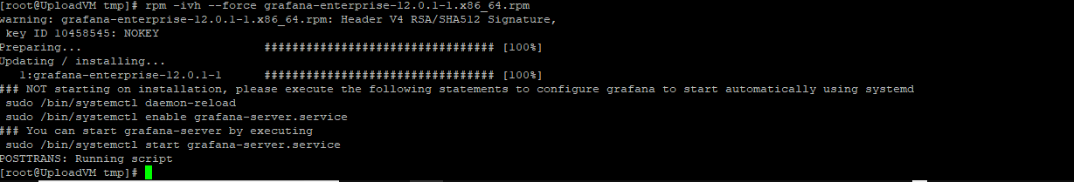
Installation completed. Reload the Daemon services and start enable ,start the grafana service

- systemctl daemon-reload
- systemctl enable --now grafana-server.service
- now check the http://ip or localhost:3000
- username: admin pwd:admin
Install the Prometheus:
Download the Prometheus.tar.gz file.
Move and extract file in OPT path
- Tar –xvzf Prometheus.tar.gz
2 Goto the extract Prometheus path copy the files in cp –r . /usr/local/bin
Run the command.
3.. ./ Prometheus --config.file=Prometheus.yml &
Now completed the Prometheus installation.
4 .. Check the 10.x.x.x:9090 = not showing the sites.
Firewall-cmd --add-port=9090/tcp –permanent
Firewall-cmd --reload

Install the node exporter on Clinet or slave machine

- Download the nodeexporter.tar.gz
- Unzip the nodeexporter.tar.gz
- Cp nodeexporter /usr/local/bin
- Run the node exporter on ./ nodeexporter &
- Now check the IP 10.x.x.x:9100 show the metrics
GOto the Master server:
Go to the Prometheus installation path:
Cd /opt/Prometheus
Vi Prometheus.yml file….
Add the clients machine IPS,

- job_name: "XXXX"
# metrics_path defaults to '/metrics'
# scheme defaults to 'http'.
static_configs:
- targets: ["10.xx.xx.13:9100"]

Save the file and gotothe
10.xx.xx.13:9090/targets
Check the status UP or DOWN
Completed the steps on Prometheus.

Now logon the Grafana Page:
Goto the the Connections add the New connections Data sources select the Prometheus = add the promethes IP 10.xx.xx.2:9090 save the connection
Goto the Dashboard import the Dashboard select json model or any other
Or Grafana.com/grafana/Dashboards

Create a services on Prometheus:
1.. Mv /opt/Prometheus /usr/local/bin/Prometheus
2.. Mkdir –p /etc/Prometheus
3.. Mv /opt/Prometheus/Prometheus.yml /etc/Prometheus/
4.. Create a directory mkdir –p /var/lib/Prometheus
5.. Enable the chown permission chown root:root /var/lib/prometheus

6… Write a service on
Cat /etc/system/system/Prometheus.service

[Unit]
Description=Prometeus
Wants=network-online.target
After=network-online.target

[Service]
User=root
ExecStart=/usr/local/bin/prometheus \
--config.file=/etc/prometheus/prometheus.yml \
--storage.tsdb.path=/var/lib/prometheus \
--web.console.templates=/usr/local/bin/consloes \
--web.console.libraries=/usr/local/bin/console_libraries

Restart=always

[Install]
WantedBy=multi-user.target

:wq! Save the file and reload the Daemon systemctl daemon-reload
7.. Now enable and start the Prometheus.service
8.. Systemctl enable –now Prometheus.service

Create a service ON node exporter:

1…Vi /etc/system/system/node_exporter.service

[Unit]
Description=node_exporter
After=network.target

[Service]
User=root
ExecStart=/tmp/node_exporter/node_exporter

[Install]
WantedBy=default.target

:wq! Save the file and reload the Daemon systemctl daemon-reload

2.. Now enable and start the node_exporter.service
3.. Systemctl enable –now node_exporter.service

